DataStructure Introduction assignments

Mandatory

- Refer the example code of single linked list.
- Modify existing data structure to include below additional data members. Update all relevant existing functions to accommodate this member update and test.
{
char id[MAX_ID_LEN]; //let max id length be 5
int val;
}
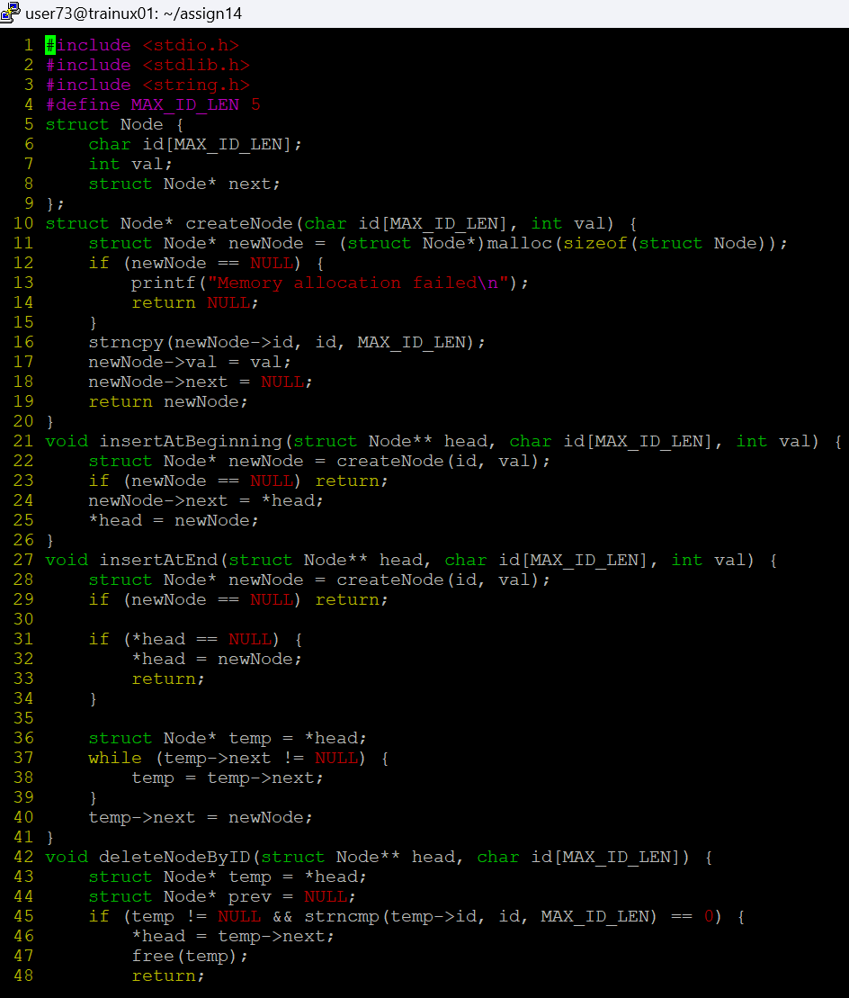
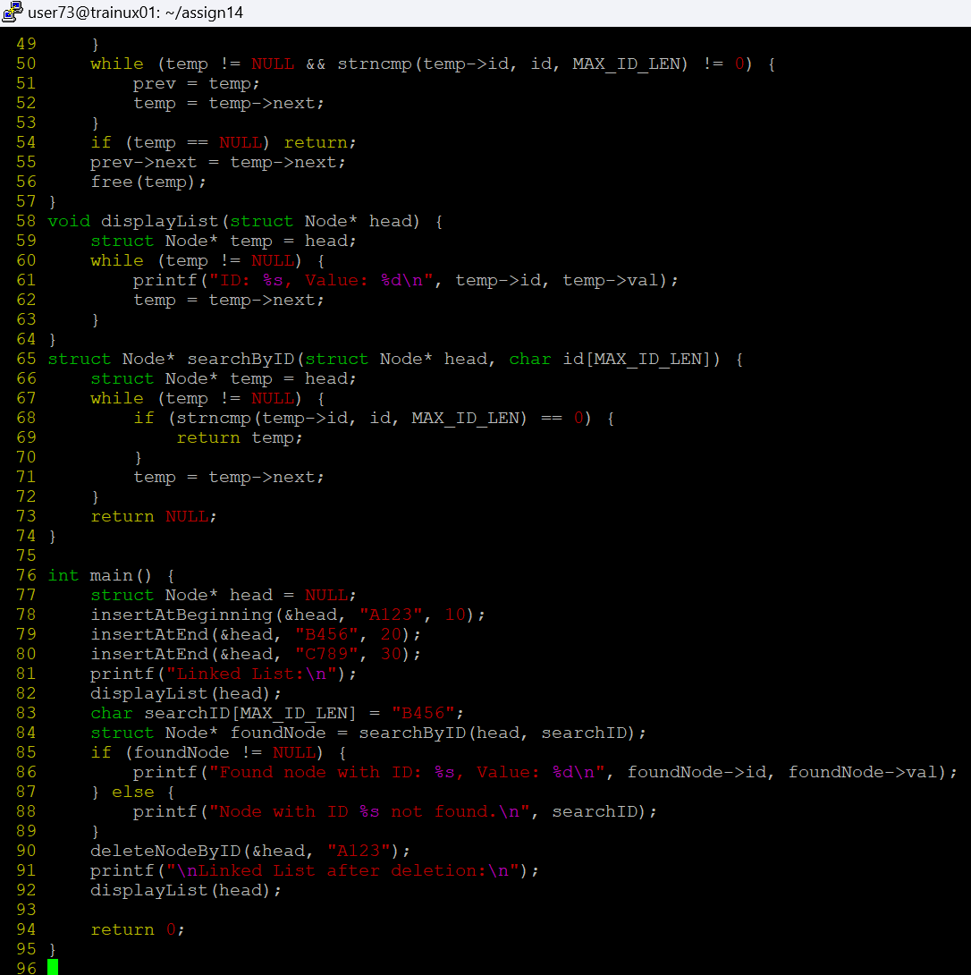
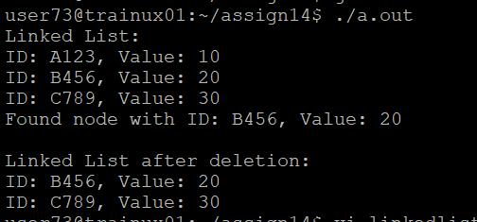
- Add a function below to perform search and update based on name (str) input.
extern int search_update_name(Node **, char *search, char *replace);
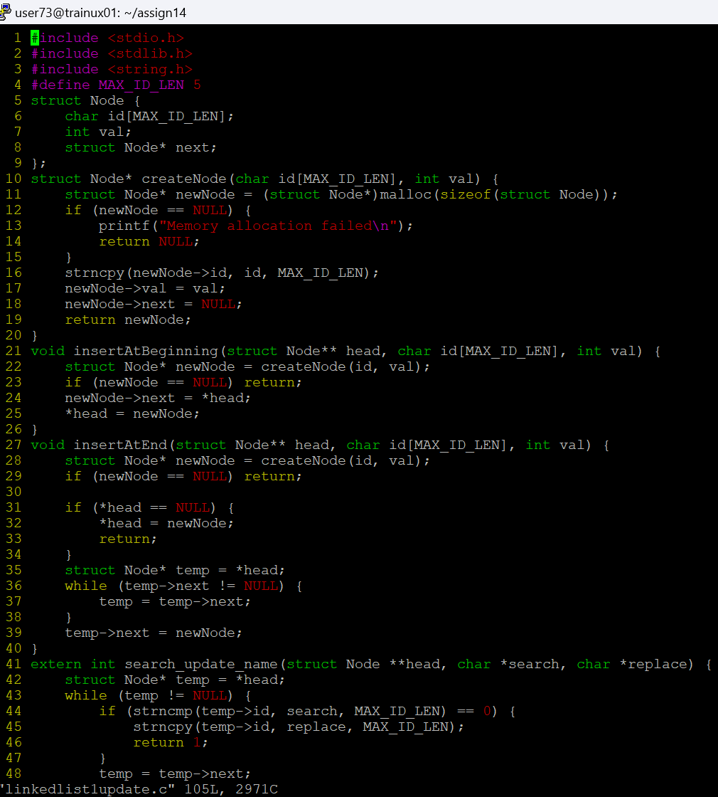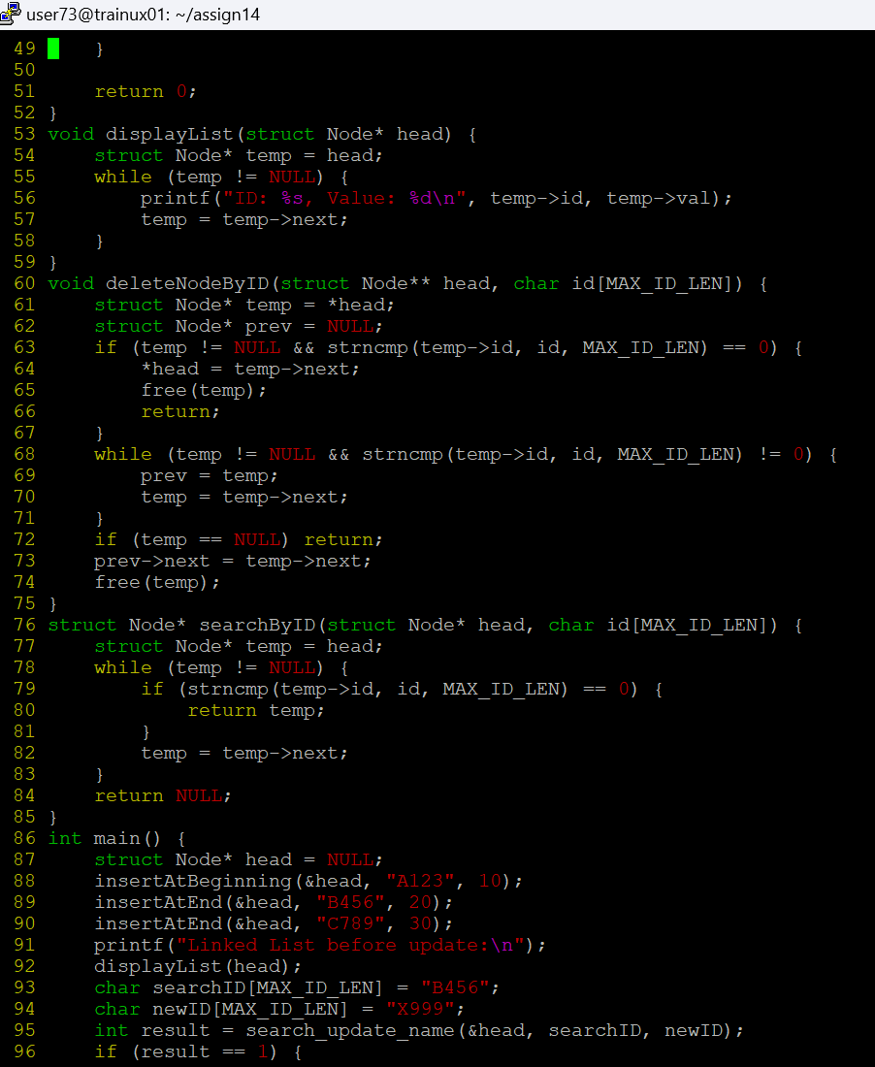

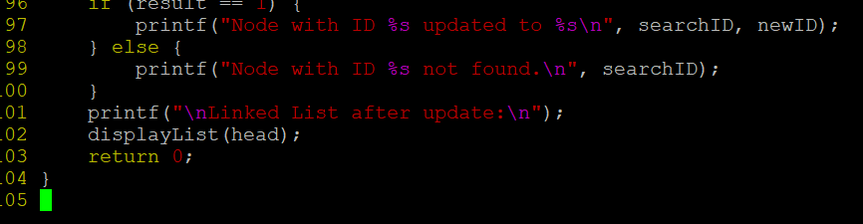

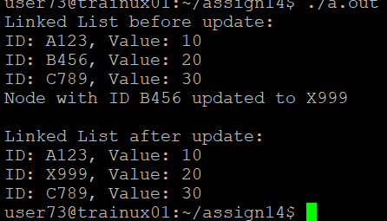
- Add functions below() to perform a sorted insert operation (ascending order) on the list based on name (str) and on val.
//insert based on name (str member) in increasing order
extern int sorted_insert_name(Node **, char *, int val);
//insert based on val in increasing order
extern int sorted_insert_val(Node **, char *, int val);

